1.Create an S3 bucket and upload some objects to S3:-
- ## Objective

- To create an Amazon S3 bucket and upload files (objects) into the bucket using the AWS Management Console.

- ## Prerequisites

- AWS Account
- IAM User with S3 permissions
- Internet Connection
- Files available on local system for upload

- ---

- ## Step 1: Log in to AWS Management Console

- Open a web browser.
- Navigate to the AWS Management Console.
- Enter IAM User credentials.
- Click **Sign In**.

- Expected Result:
- Successfully logged into the AWS Management Console.

- ---

- ## Step 2: Open Amazon S3 Service

- In the AWS Console search bar, type **S3**.
- Select **Amazon S3** from the search results.

- Expected Result:
- Amazon S3 Dashboard is displayed.

- ---

- ## Step 3: Create a New S3 Bucket

- Click **Create bucket**.
- Enter a globally unique bucket name.
- Example:

- ```
- salman-s3-bucket-2026
- ```
- Select the AWS Region.
- Example:

- ```
- US East (N. Virginia) - us-east-1
- ```
- Keep **ACLs Disabled (Recommended)** selected.
- Leave **Block Public Access** enabled.
- Keep **Bucket Versioning** disabled.
- Select **Server-Side Encryption with Amazon S3 Managed Keys (SSE-S3)**.
- Click **Create Bucket**.

- Expected Result:
- The S3 bucket is successfully created and appears in the bucket list.

- ---

- ## Step 4: Open the Created Bucket

- From the S3 bucket list, select the newly created bucket.
- Open the bucket.

- Expected Result:
- The bucket opens and displays the Objects tab.

- ---

- ## Step 5: Upload Files to the Bucket

- Click **Upload**.
- Click **Add Files**.
- Select files from the local machine.
- Example:

- resume.pdf
- image.jpg
- notes.txt
- Click **Open**.
- Review upload settings.
- Click **Upload**.

- Expected Result:
- Files are successfully uploaded to the S3 bucket.

- ---

- ## Step 6: Verify Uploaded Objects

- Navigate to the **Objects** tab.
- Verify that uploaded files are listed.

- Expected Result:
- Uploaded objects are visible in the bucket.

- ---

- ## Step 7: View Object Details

- Click on any uploaded object.
- Review object information such as:

- Object Name
- Size
- Storage Class
- Last Modified Date
- Encryption Details

- Expected Result:
- Object properties are displayed successfully.

- ---

- ## Step 8: Download an Object

- Select the required object.
- Click **Download**.

- Expected Result:
- The selected object is downloaded to the local system.

- ---

- ## Step 9: Delete an Object

- Select the object.
- Click **Delete**.
- Confirm deletion.

- Expected Result:
- The selected object is permanently removed from the bucket.

- ---

- ## Architecture Flow

- Local System
- ↓
- Select File
- ↓
- Upload Request
- ↓
- Amazon S3 Bucket
- ↓
- Object Stored Successfully
- ↓
- Access / Download / Delete

- ---

- Also we can create S3 bucket and paste the file by using CLI Commands through Git Bash or Launch Instance in AWS. Below are the steps:-

# Practical: Create an Amazon S3 Bucket and Upload Objects Using AWS CLI

## Objective

To create an Amazon S3 bucket and upload files (objects) using the AWS Command Line Interface (CLI).

## Prerequisites

* AWS Account
* IAM User with S3 permissions
* AWS CLI installed on local machine
* Access Key and Secret Key configured
* Internet connectivity

---

## Step 1: Verify AWS CLI Installation

Open Command Prompt, PowerShell, Git Bash, or Terminal and execute:

```bash
aws --version
```

Expected Output:

```bash
aws-cli/2.x.x
```

Expected Result:
AWS CLI is installed successfully.

---

## Step 2: Configure AWS CLI

Execute the following command:

```bash
aws configure
```

Provide the following details:

```text
AWS Access Key ID: XXXXXXXXXXXXX
AWS Secret Access Key: XXXXXXXXXXXXX
Default region name: us-east-1
Default output format: json
```

Expected Result:
AWS credentials are configured successfully.

---

## Step 3: Verify IAM User Access

Run:

```bash
aws sts get-caller-identity
```

Expected Output:

```json
{
"UserId": "AIDXXXXXXXXXXXX",
"Account": "123456789012",
"Arn": "arn:aws:iam::123456789012:user/salman"
}
```

Expected Result:
AWS CLI successfully authenticates the IAM user.

---

## Step 4: Create an S3 Bucket

For us-east-1 Region:

```bash
aws s3 mb s3://salman-s3-bucket-2026
```

Expected Output:

```text
make_bucket: salman-s3-bucket-2026
```

Expected Result:
S3 bucket is created successfully.

---

## Step 5: Verify Bucket Creation

Execute:

```bash
aws s3 ls
```

Expected Output:

```text
2026-06-11 15:20:00 salman-s3-bucket-2026
```

Expected Result:
Newly created bucket appears in the bucket list.

---

## Step 6: Create Sample Files

Create files on your local machine:

```text
resume.txt
notes.txt
image.jpg
```

Store them in a folder such as:

```text
C:\S3Files
```

Expected Result:
Files are ready for upload.

---

## Step 7: Upload a Single File

Navigate to the file location and execute:

```bash
aws s3 cp resume.txt s3://salman-s3-bucket-2026
```

Expected Output:

```text
upload: ./resume.txt to s3://salman-s3-bucket-2026/resume.txt
```

Expected Result:
Single file uploaded successfully.

---

## Architecture Flow

AWS CLI
↓
AWS Credentials Validation
↓
Create S3 Bucket
↓
Upload Objects

---

## Conclusion

Using AWS CLI, an Amazon S3 bucket was created successfully. Files were uploaded, verified, downloaded, and deleted. AWS CLI provides a fast and efficient method to manage S3 resources through command-line operations and automation scripts.

- ## Conclusion

- The Amazon S3 bucket was successfully created, and objects were uploaded, verified, downloaded, and deleted using the AWS Management Console. Amazon S3 provides highly scalable, durable, and secure object storage for storing files, backups, logs, images, and application data.

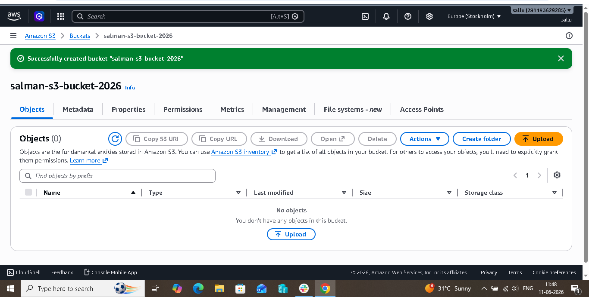
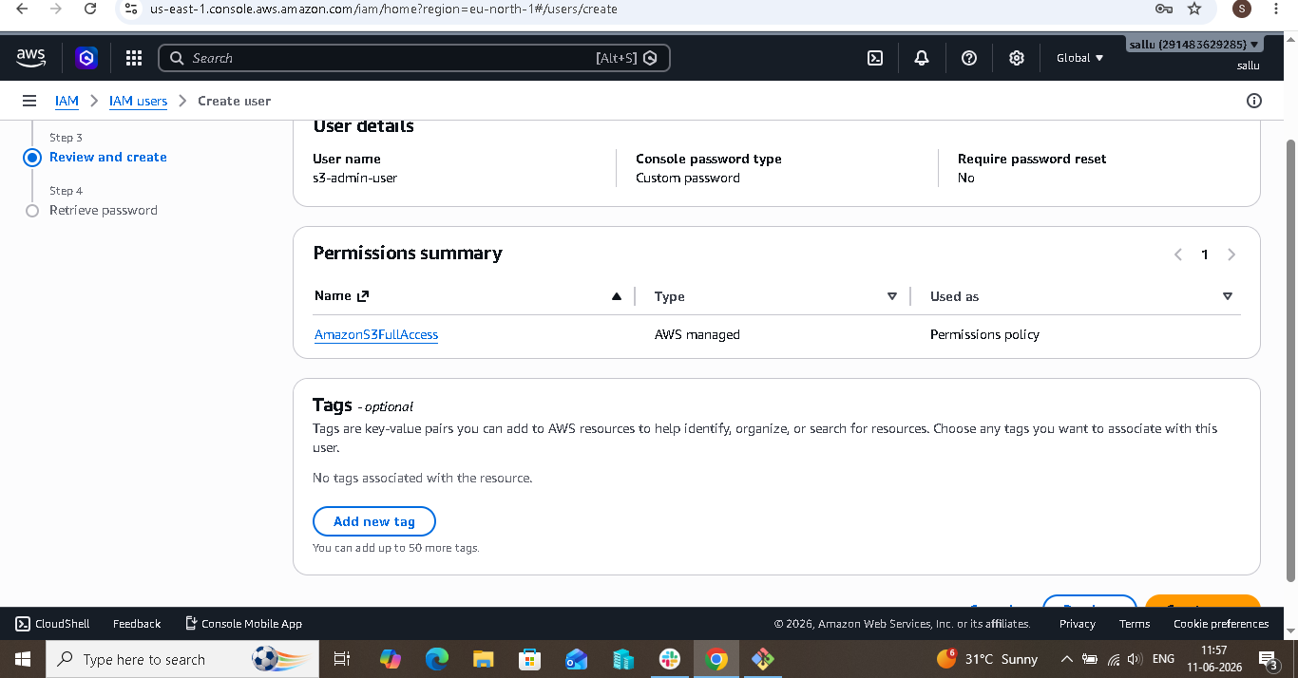
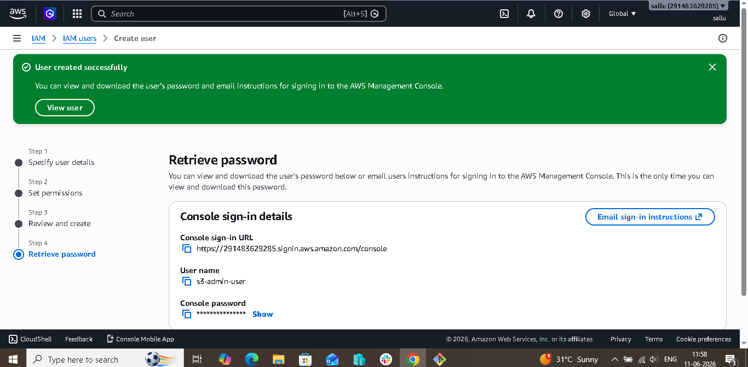
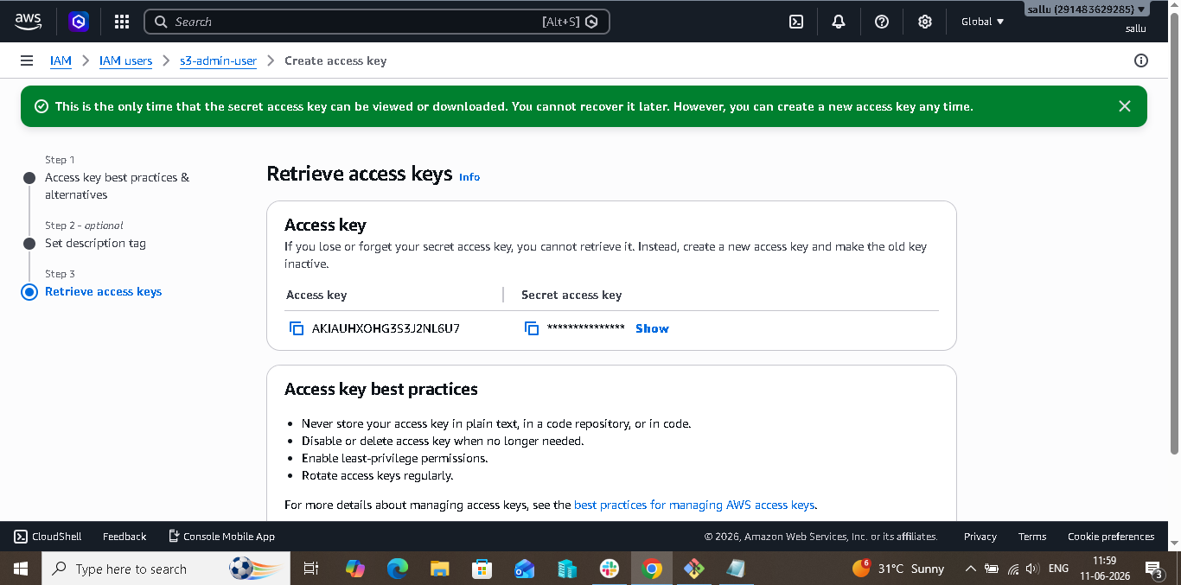
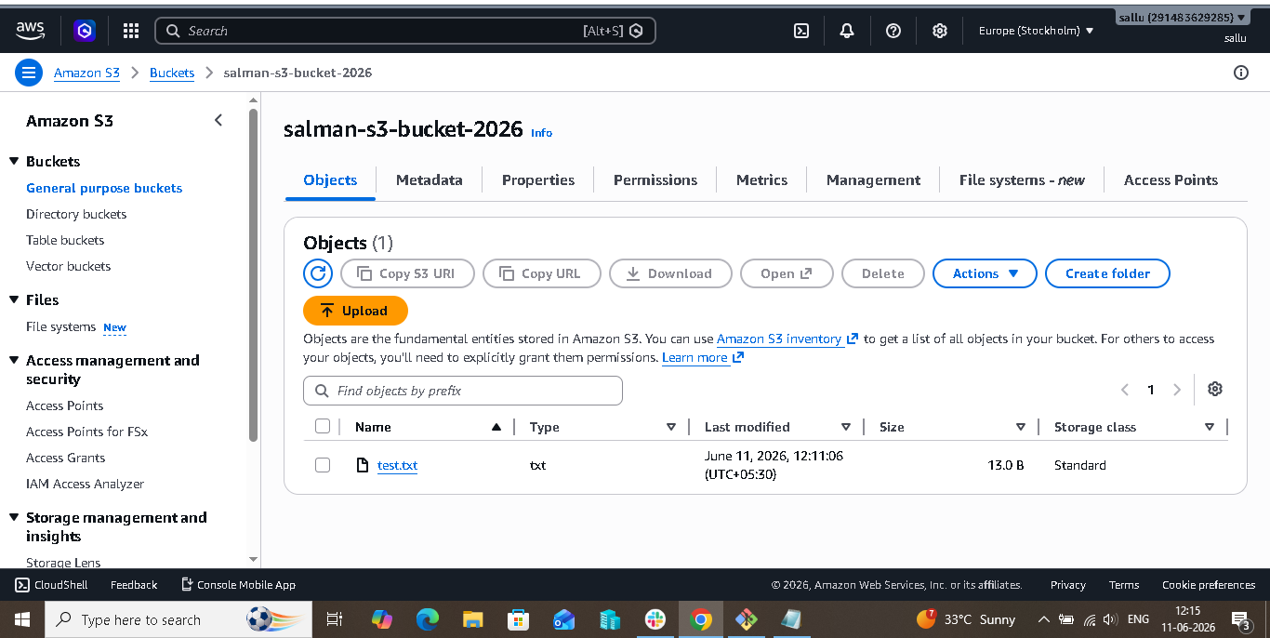
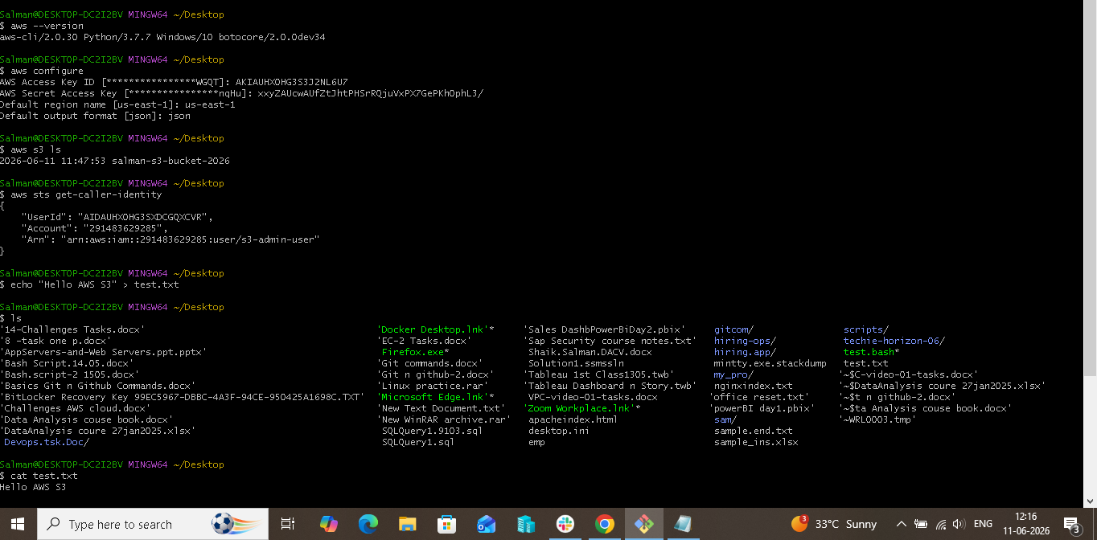
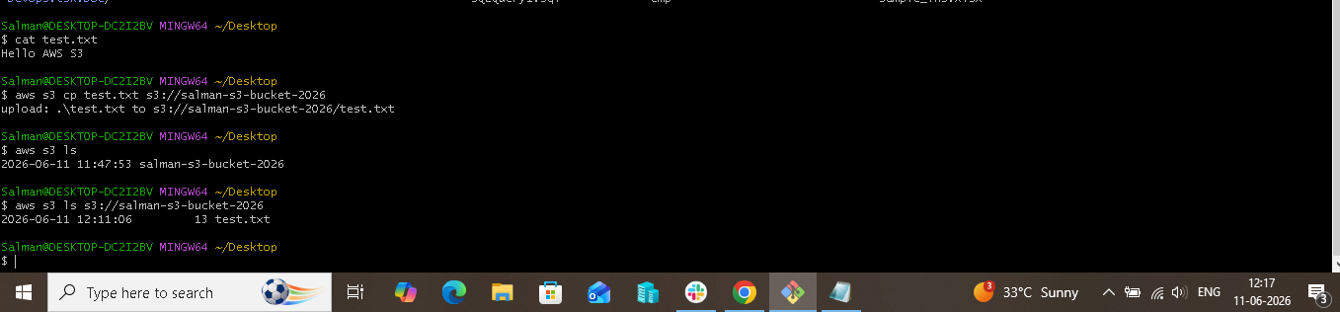

2. Deploy a static website in the S3 bucket:-

- ## Aim

- To host a static website using Amazon S3 by creating an S3 bucket, uploading website files, enabling static website hosting, configuring public access permissions, and verifying the website through the S3 website endpoint.

- ---

- ## Prerequisites

- AWS Account
- IAM User with S3 permissions
- Basic knowledge of HTML
- Web browser
- Sample website files (index.html and error.html)

- ---

- ## Architecture

- User Browser
- ↓
- S3 Static Website Endpoint
- ↓
- Amazon S3 Bucket
- ↓
- index.html
- error.html

- ---

- ## Procedure

- ### Step 1: Create an S3 Bucket

- Log in to the AWS Management Console.
- Navigate to Amazon S3.
- Click **Create Bucket**.
- Enter a globally unique bucket name:

- ```
- salman-static-website-2026-11
- ```
- Select Region:

- ```
- us-east-1
- ```
- Leave all other settings as default.
- Click **Create Bucket**.

- Expected Result:
- The S3 bucket is created successfully.

- ---

- ### Step 2: Disable Block Public Access

- Open the newly created bucket.
- Select the **Permissions** tab.
- Under **Block Public Access**, click **Edit**.
- Uncheck **Block all public access**.
- Acknowledge the warning message.
- Save changes.

- Expected Result:
- The bucket can serve publicly accessible website content.

- ---

- ### Step 3: Create Website Files

- Create a file named **index.html** with the following content:

- ```html
- <!DOCTYPE html>
- <html>
- <head>
- <title>My First S3 Website</title>
- </head>
- <body>
- <h1>Welcome to My Static Website</h1>
- <p>Hosted on Amazon S3</p>
- </body>
- </html>
- ```

- Create a file named **error.html** with the following content:

- ```html
- <!DOCTYPE html>
- <html>
- <head>
- <title>Error Page</title>
- </head>
- <body>
- <h1>404 Error</h1>
- <p>Page Not Found</p>
- </body>
- </html>
- ```

- Expected Result:
- Website files are ready for upload.

- ---

- ### Step 4: Upload Website Files

- Open the bucket.
- Navigate to the **Objects** tab.
- Click **Upload**.
- Select:

- index.html
- error.html
- Click **Upload**.

- Expected Result:
- Website files are successfully uploaded to the bucket.

- ---

- ### Step 5: Enable Static Website Hosting

- Open the bucket.
- Select the **Properties** tab.
- Scroll to **Static Website Hosting**.
- Click **Edit**.
- Select **Enable**.
- Choose **Host a Static Website**.
- Enter:

- ```
- Index Document: index.html
- Error Document: error.html
- ```
- Save changes.

- Expected Result:
- Static website hosting is enabled.

- ---

- ### Step 6: Configure Bucket Policy

- Navigate to the **Permissions** tab.
- Under **Bucket Policy**, click **Edit**.
- Paste the following policy:

- ```json
- {
- "Version": "2012-10-17",
- "Statement": [
- {
- "Sid": "PublicReadAccess",
- "Effect": "Allow",
- "Principal": "*",
- "Action": "s3:GetObject",
- "Resource": "arn:aws:s3:::salman-static-website-2026-11/*"
- }
- ]
- }
- ```

- Save the policy.

- Expected Result:
- Public users can access website files.

- ---

- ### Step 7: Access the Website

- Open the **Properties** tab.
- Scroll to **Static Website Hosting**.
- Copy the Website Endpoint URL.
- Open the URL in a web browser.

- Expected Result:

- The following page is displayed:

- Welcome to My Static Website

- Hosted on Amazon S3

- ---

- ### Step 8: Verify the Custom Error Page

- Append a non-existing page name to the website URL.

- Example:

- ```
- http://salman-static-website-2026-11.s3-website-us-east-1.amazonaws.com/test.html
- ```

- Press Enter.

- Expected Result:

- The custom error page is displayed:

- ```
- 404 Error
- Page Not Found
- ```

- This confirms that the custom error document configuration is functioning correctly.

- ---

- ## Output

- The static website was successfully deployed and hosted using Amazon S3 Static Website Hosting. The website homepage was accessible through the S3 website endpoint, and the custom error page was displayed when an invalid URL was requested.

- ---

- ## Conclusion

- Amazon S3 Static Website Hosting provides a simple, scalable, and cost-effective method for hosting static websites without managing web servers. By creating an S3 bucket, uploading website files, enabling static website hosting, configuring bucket permissions, and validating both the homepage and error page, a fully functional static website was successfully deployed.

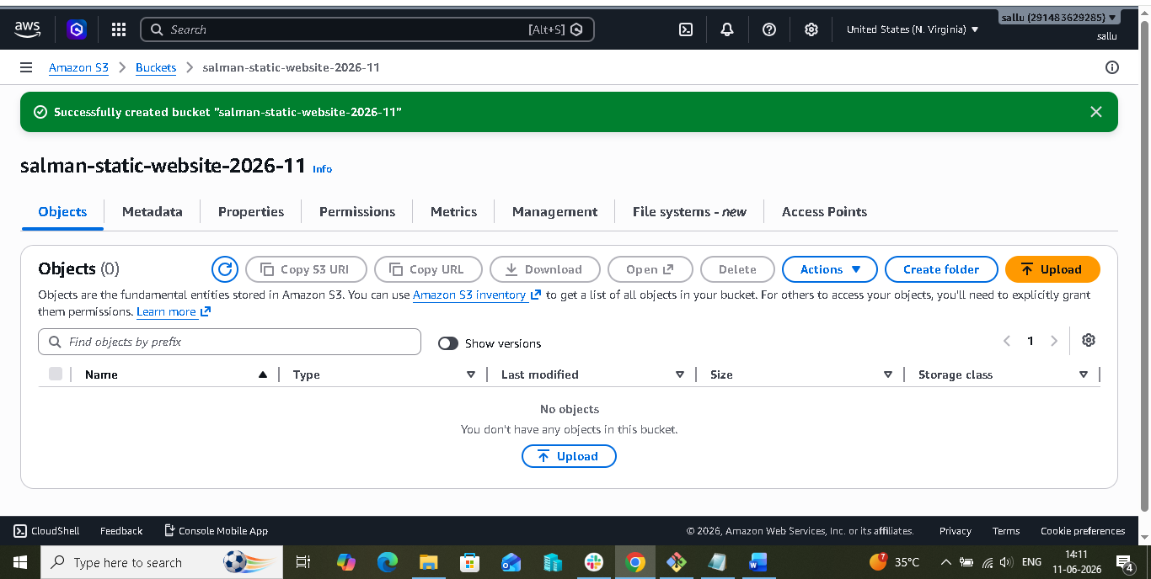

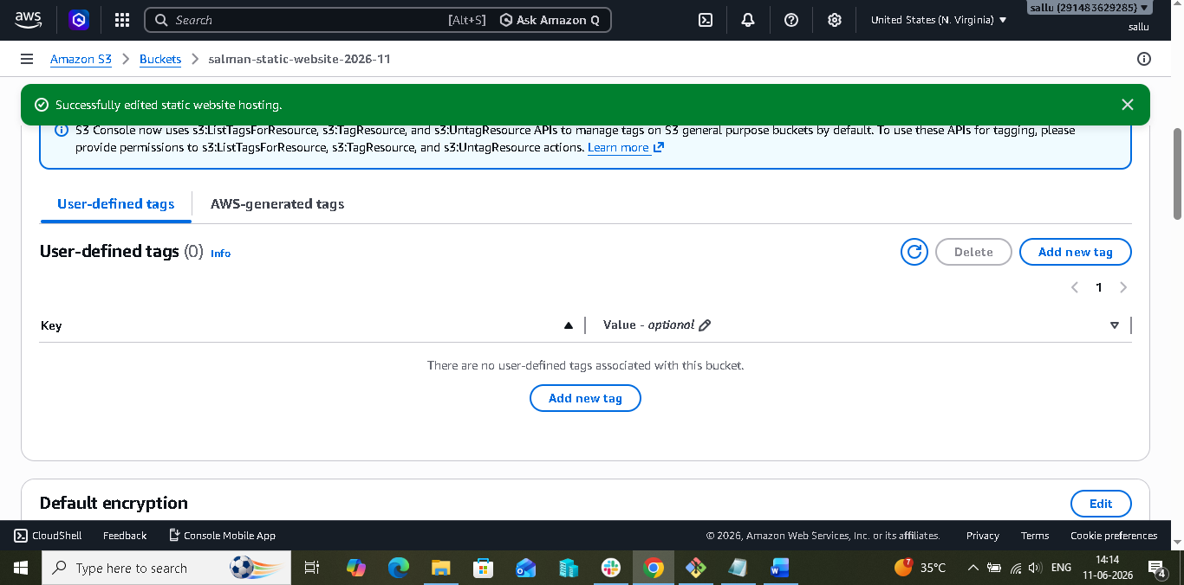

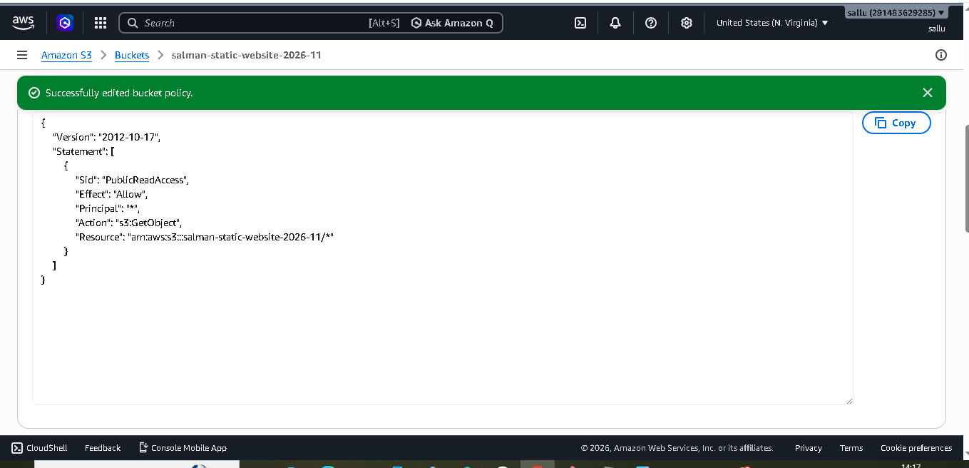

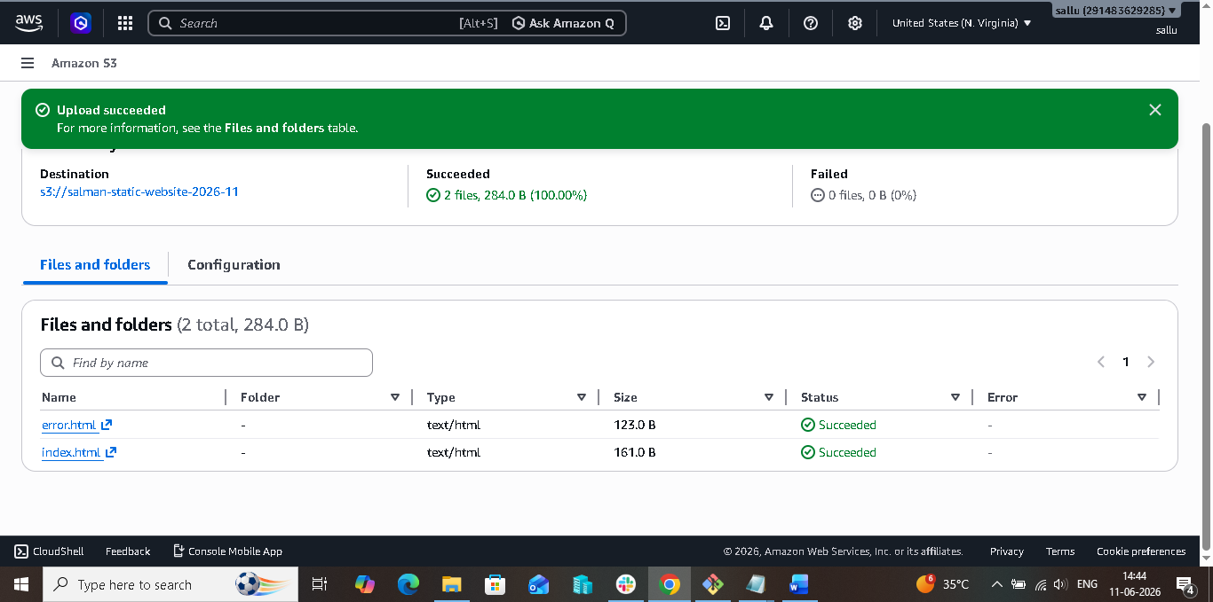
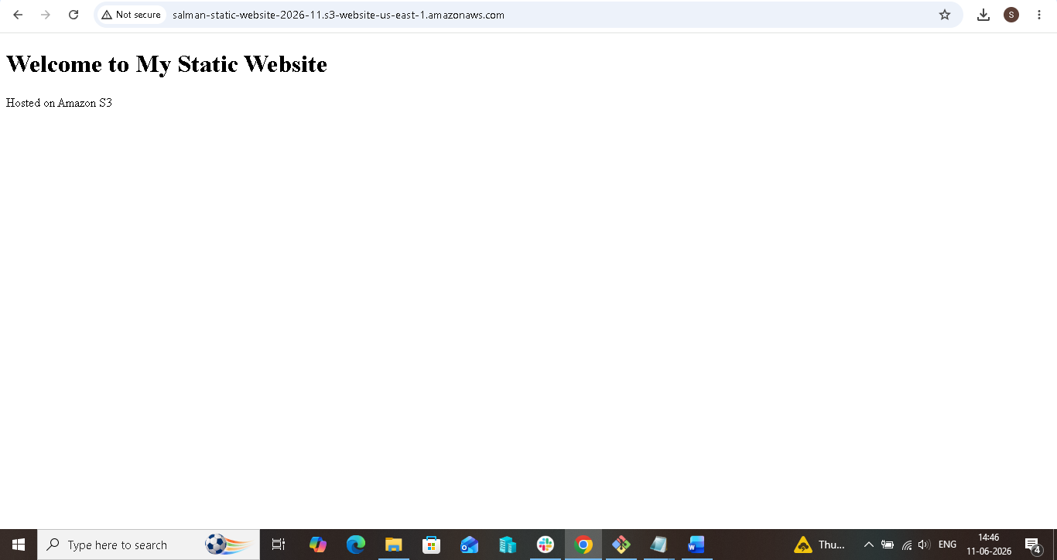

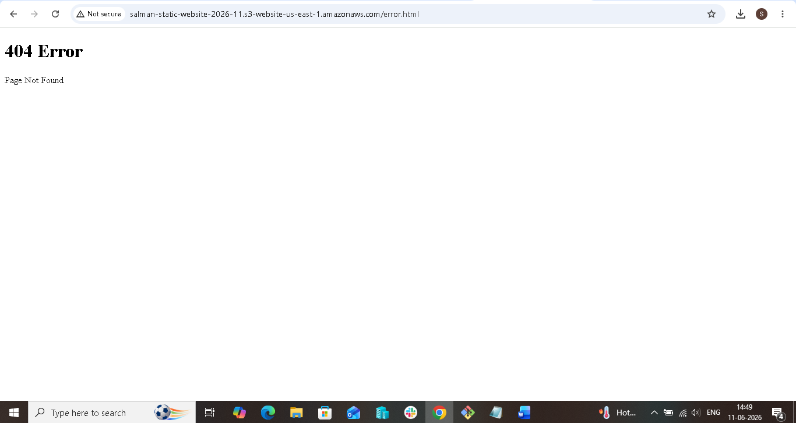

3. Enable cross-region replication on S3 buckets:-

## Objective

To configure Cross-Region Replication between two S3 buckets located in different AWS regions.

## Procedure

1. Create a source S3 bucket in **us-east-1 (N. Virginia)**.
2. Create a destination S3 bucket in **us-east-2 (Ohio)**.
3. Enable **Versioning** on both source and destination buckets.
4. Open the source bucket and navigate to **Management → Replication Rules**.
5. Click **Create Replication Rule**.
6. Enter a rule name and select **Apply to all objects**.
7. Choose **Destination bucket in another region** and select the Ohio bucket.
8. Allow AWS to create the required **IAM Replication Role** automatically.
9. Review the configuration and save the replication rule.
10. Upload a test file to the source bucket.
11. Verify that the file is automatically replicated to the destination bucket.

## Architecture

Source Bucket (us-east-1)
↓
Cross-Region Replication
↓
Destination Bucket (us-east-2)

## Result

Successfully configured Cross-Region Replication between S3 buckets in different AWS regions. Files uploaded to the source bucket are automatically replicated to the destination bucket in Ohio (us-east-2).

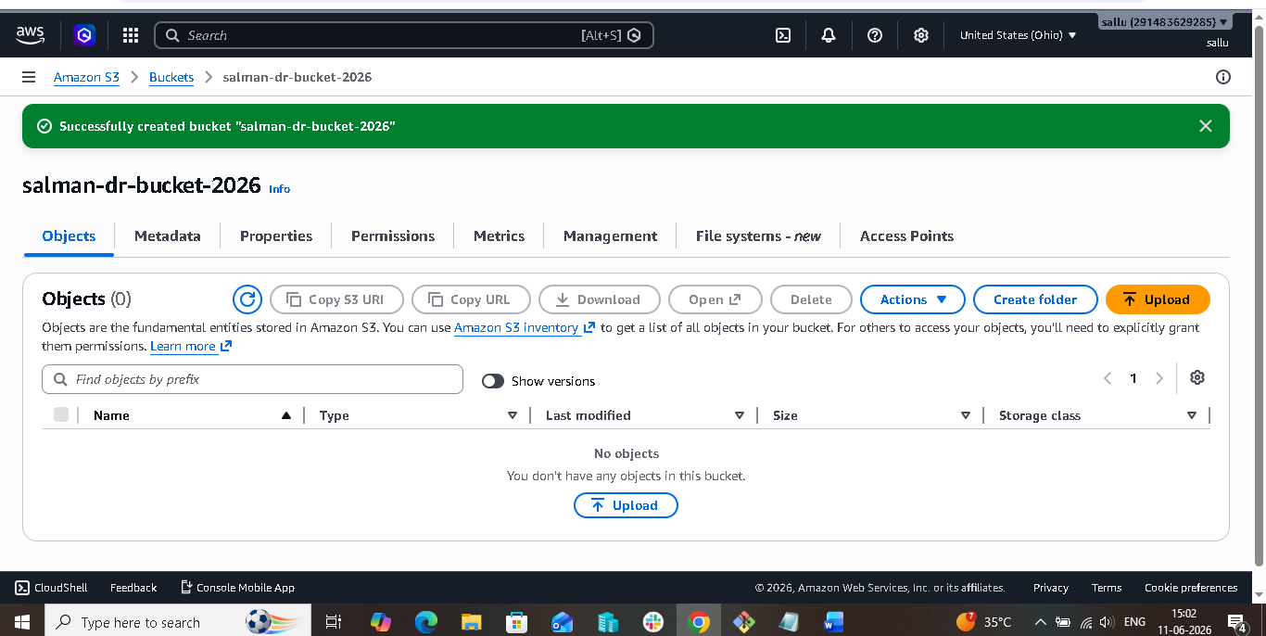

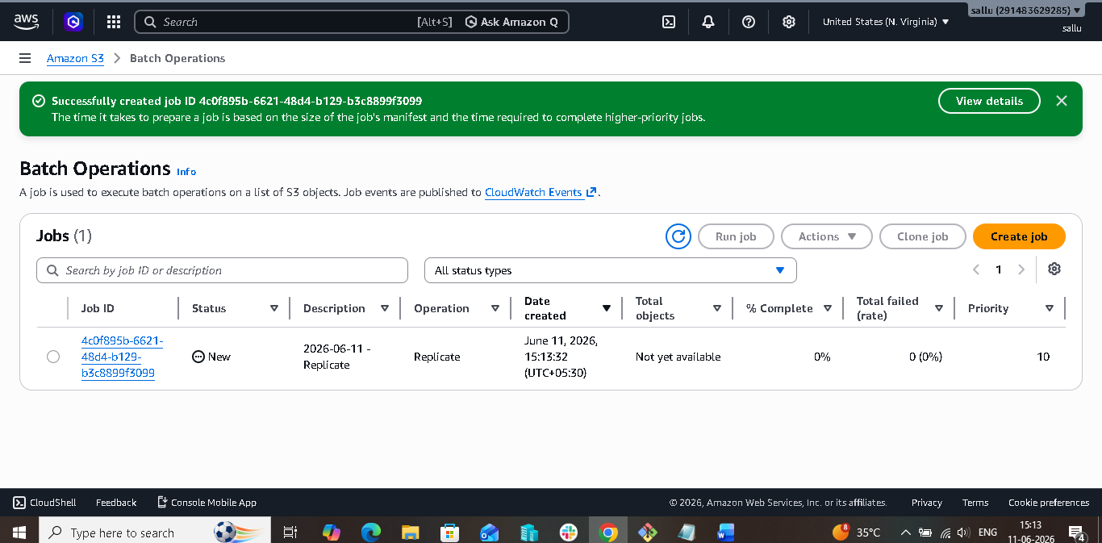

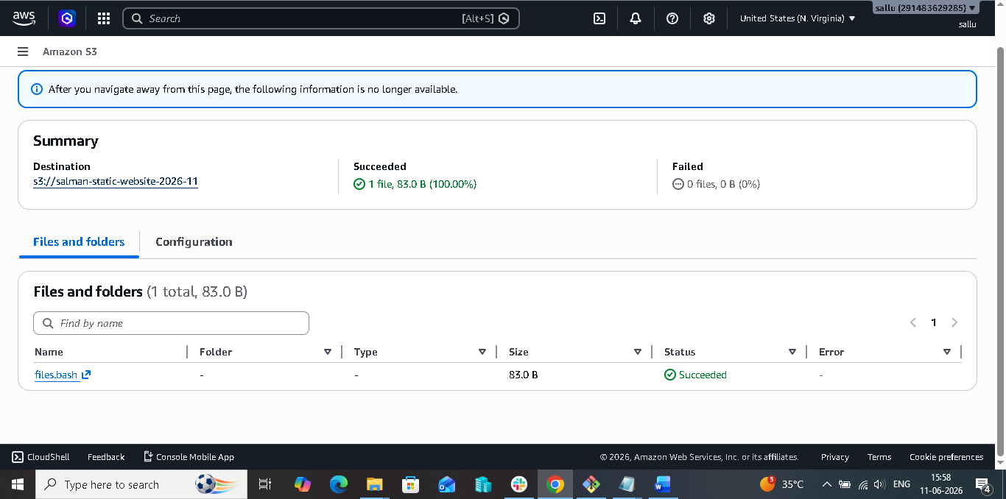

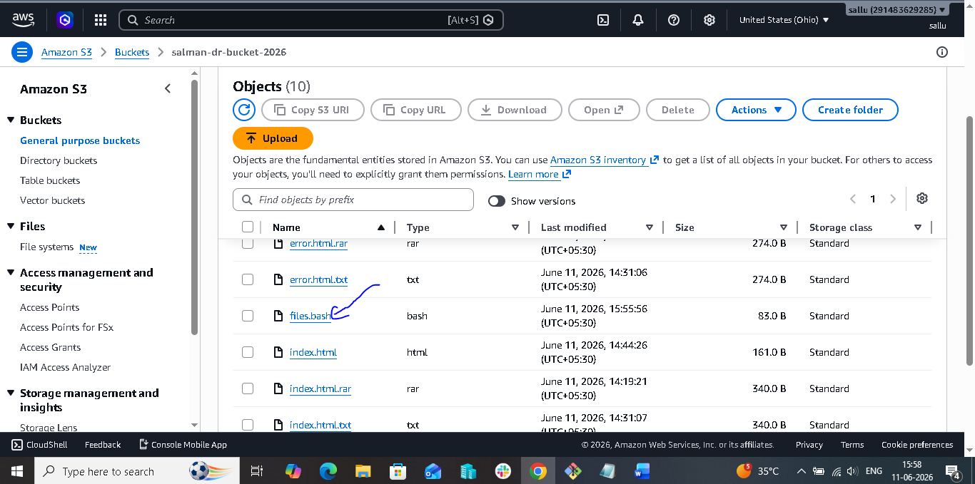

4. Configure a bucket policy so only the Admin user can see the objects of the S3 bucket:-

- ## Objective

- To configure an S3 bucket policy that allows only the Admin IAM user to view and access objects stored in the S3 bucket.

- ## Step 1: Create an S3 Bucket

- Log in to the AWS Management Console.
- Navigate to Amazon S3.
- Click **Create Bucket**.
- Enter a unique bucket name.
- Select the desired AWS Region.
- Click **Create Bucket**.

- ## Step 2: Create an IAM User

- Navigate to IAM Service.
- Select **Users** and click **Create User**.
- Enter the username **Admin**.
- Attach the **AdministratorAccess** policy.
- Click **Create User**.

- ## Step 3: Upload an Object

- Open the S3 bucket.
- Click **Upload**.
- Select a sample file (Example: test.txt).
- Click **Upload**.

- ## Step 4: Copy the Admin User ARN

- Open the Admin IAM user.
- Copy the User ARN.

- Example:

- arn:aws:iam::291483629285:user/Admin

- ## Step 5: Configure Bucket Policy

- Open the S3 bucket.
- Go to the **Permissions** tab.
- Select **Bucket Policy**.
- Click **Edit**.
- Paste the bucket policy and replace the Account ID and Bucket Name with your values.
- Click **Save Changes**.

- The policy grants access only to the Admin IAM user for listing and viewing bucket objects.

- ## Step 6: Verify Access

- Sign in as the Admin user.
- Open the S3 bucket.
- Verify that objects can be viewed and downloaded.

- ## Step 7: Test with Another User

- Sign in using a different IAM user.
- Attempt to access the bucket objects.
- Access should be denied.

- ## Result

- Successfully configured an S3 bucket policy that allows only the Admin IAM user to access and view objects stored in the S3 bucket, while restricting access for other users.

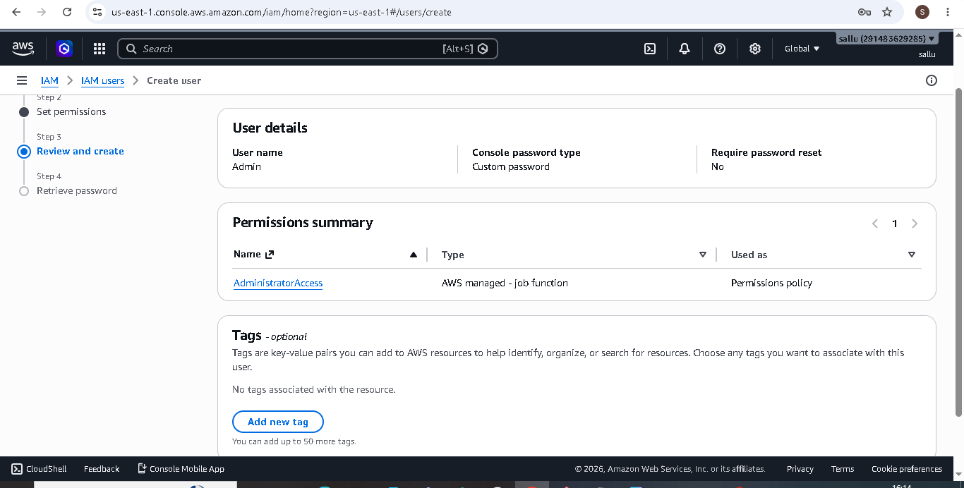

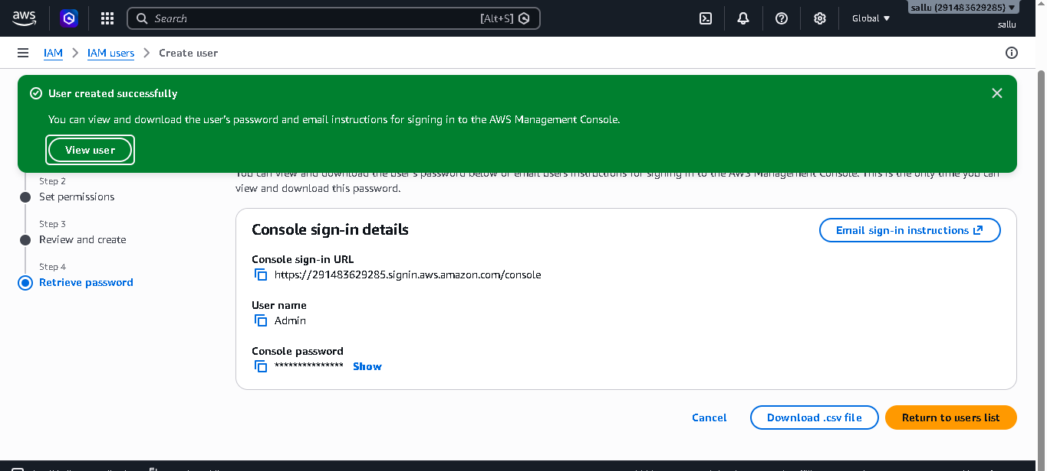

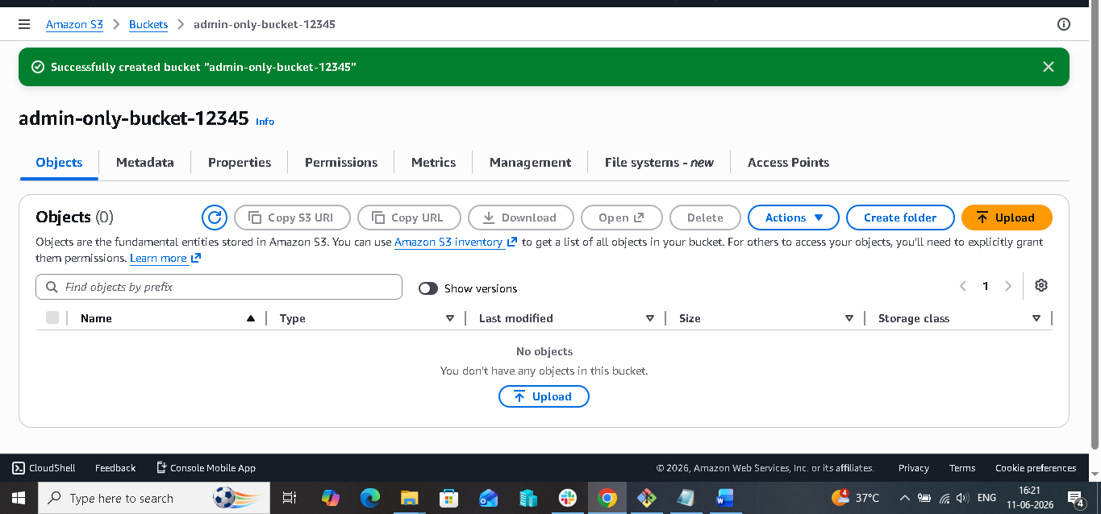

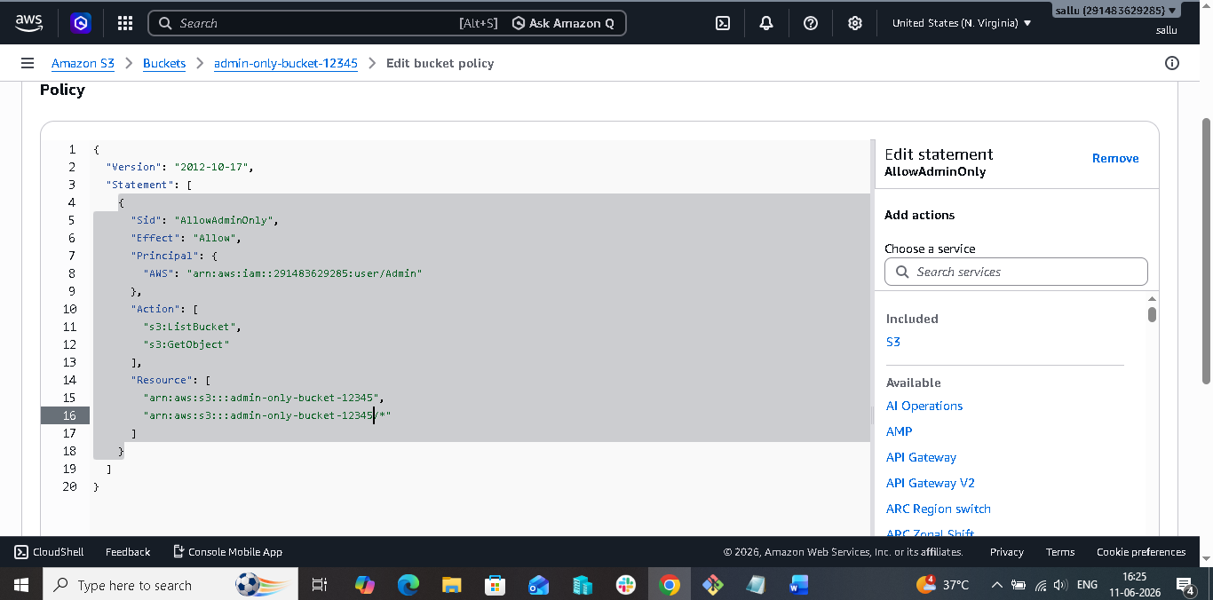

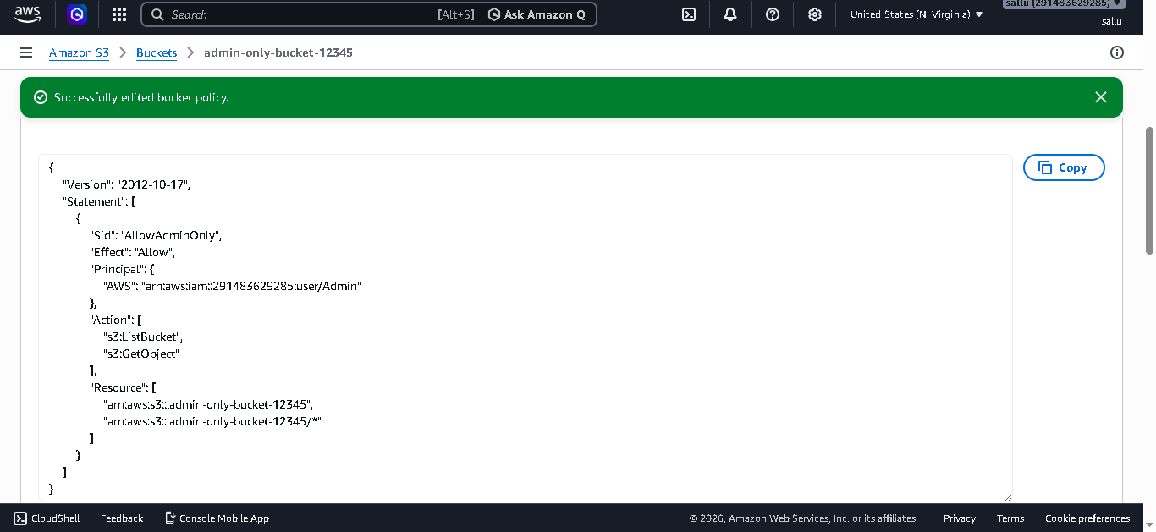

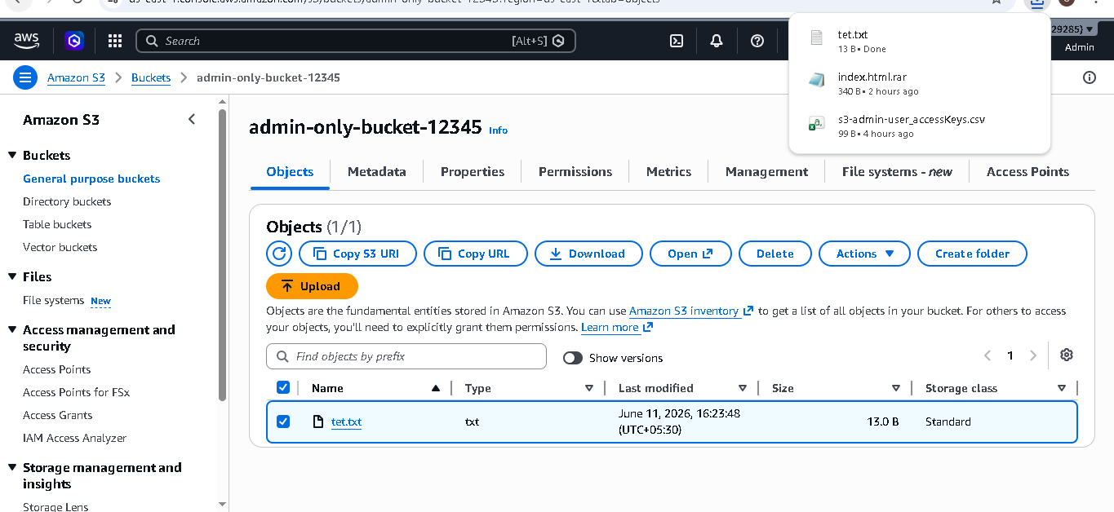

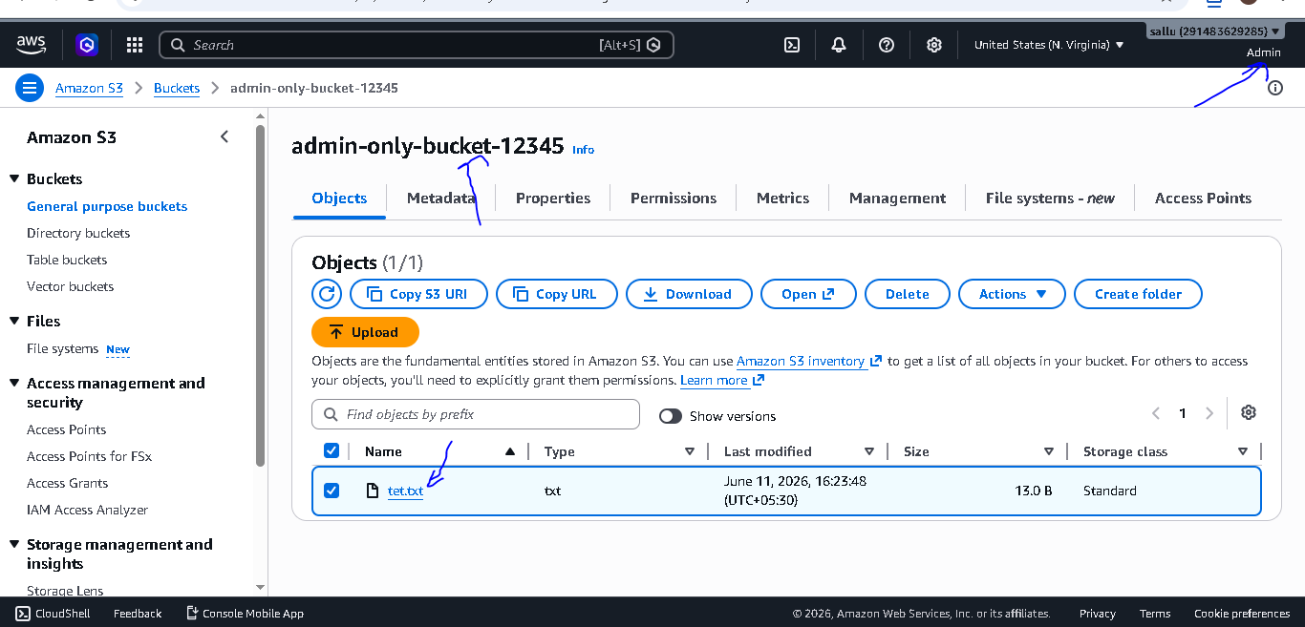

5. Set up lifecycle policies to automatically transition or delete objects based on specific criteria:-

- # Set Up Lifecycle Policies on an S3 Bucket

- ## Objective

- To automatically transition and delete S3 objects using a Lifecycle Policy.

- ## Steps

- Log in to AWS Management Console.
- Open Amazon S3 and create a bucket named **lifecycle-bucket-123456.
- Upload a sample file to the bucket.
- Open the bucket and select the **Management** tab.
- Click **Create Lifecycle Rule**.
- Enter the rule name **Lifecycle-Rule**.
- Select **Apply to all objects in the bucket**.
- Under Lifecycle Rule Actions, select:

- **Transition current versions of objects between storage classes**
- **Expire current versions of objects**
- Configure:

- Transition after **30 days** to **Standard-IA**
- Expire objects after **365 days**
- Review the configuration and click **Create Rule**.

- ## Result

- Successfully configured an S3 Lifecycle Policy that automatically moves objects to Standard-IA after 30 days and permanently deletes them after 365 days.

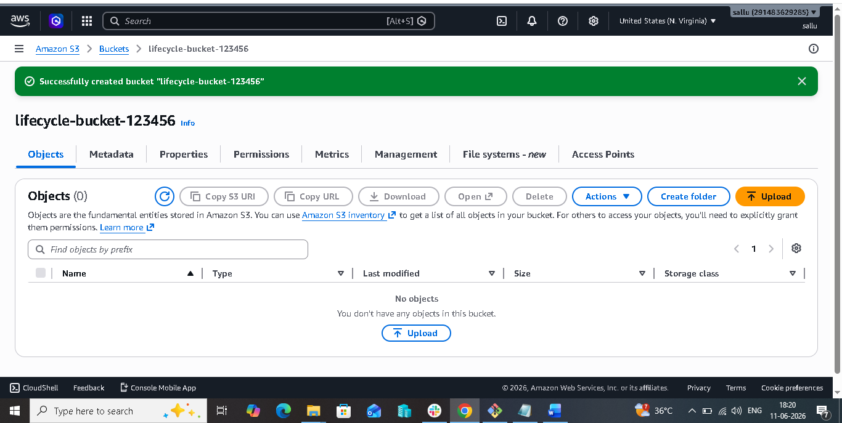

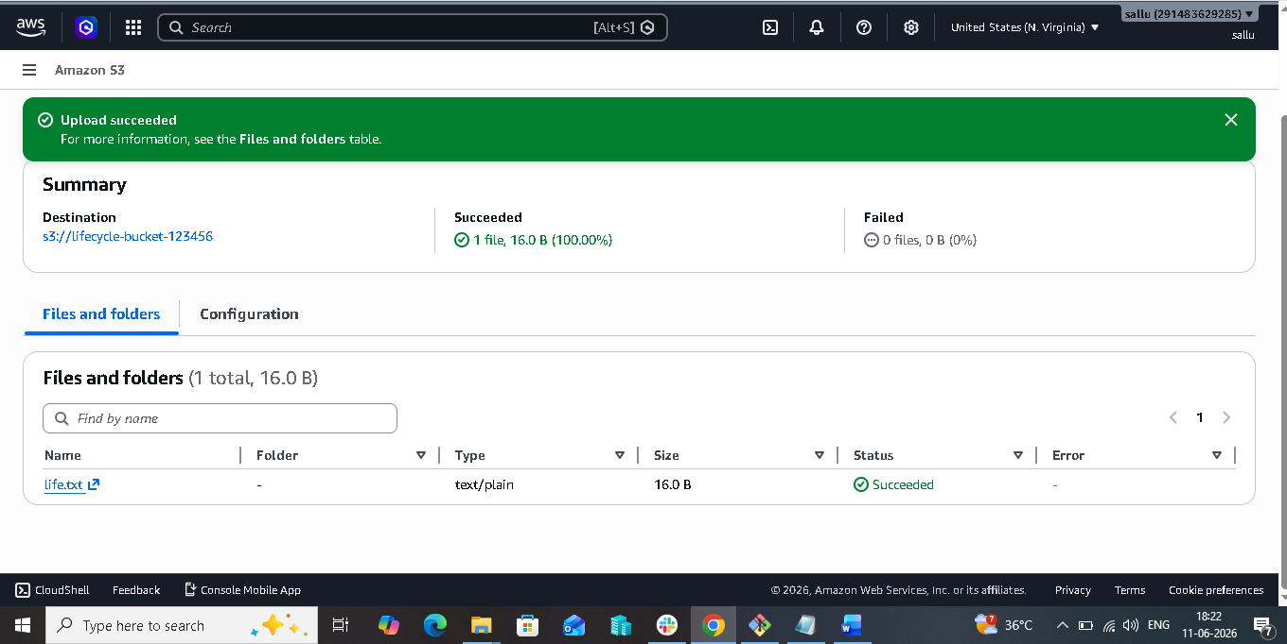

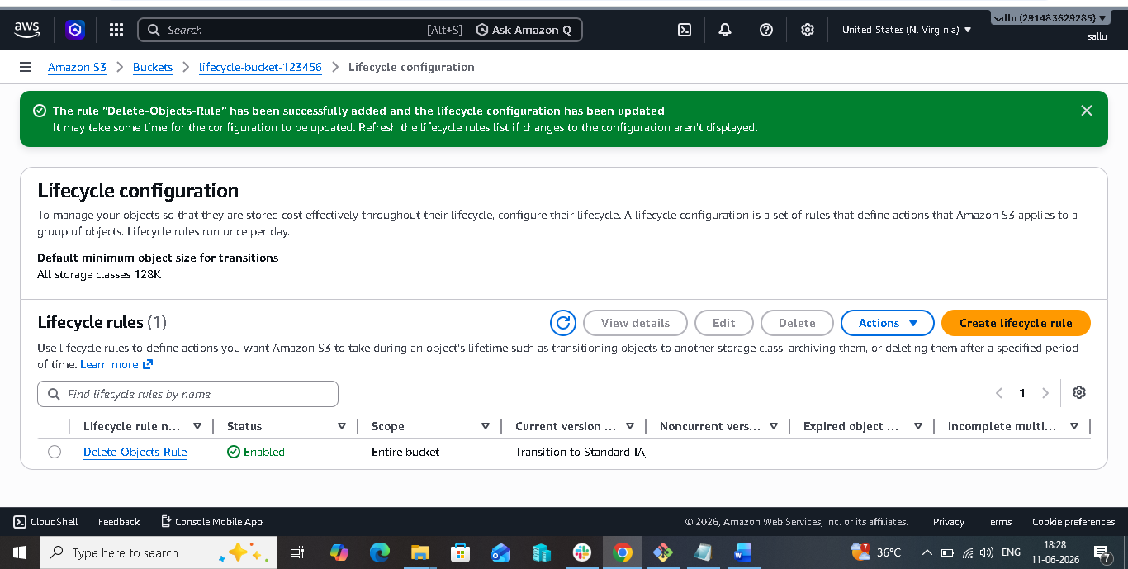

6. Push some objects to S3 using the AWS CLI:-

## Objective

To upload files from a local system to an Amazon S3 bucket using AWS CLI.

## Steps

1. Log in to AWS and create an S3 bucket.

2. Install AWS CLI on the local machine.

3. Configure AWS CLI using:

aws configure

4. Enter the Access Key, Secret Key, Region, and Output Format.

5. Create sample files such as file1.txt and file2.txt.

6. Open Command Prompt or Git Bash and navigate to the file location.

7. Upload a single file using:

aws s3 cp file1.txt s3://bucket-name/

8. Upload multiple files using:

aws s3 cp . s3://bucket-name/ --recursive

9. Verify the uploaded files using:

aws s3 ls s3://bucket-name/

## Result

Successfully uploaded objects from the local machine to an Amazon S3 bucket using AWS CLI and verified the uploaded files.

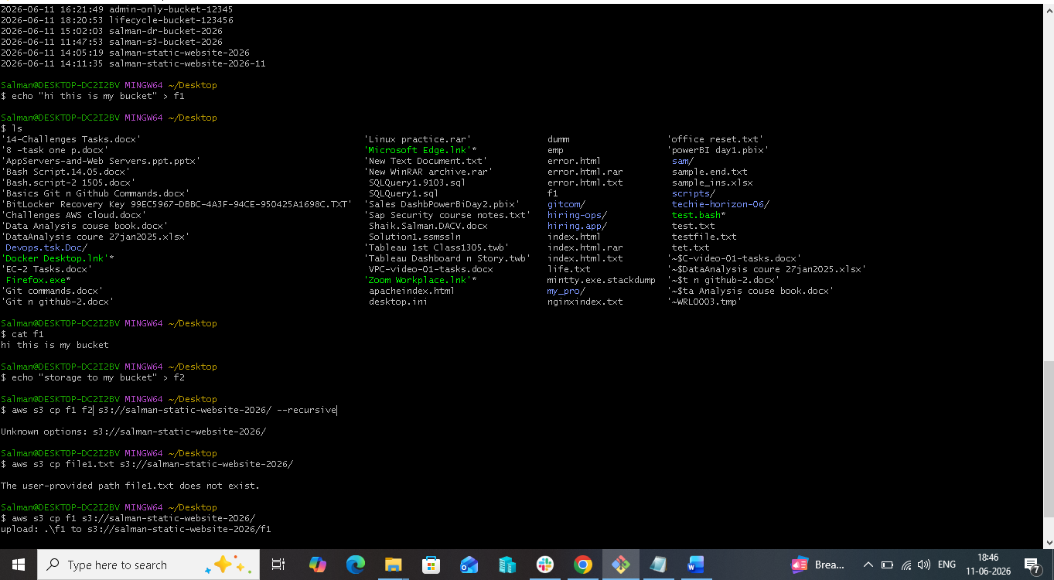

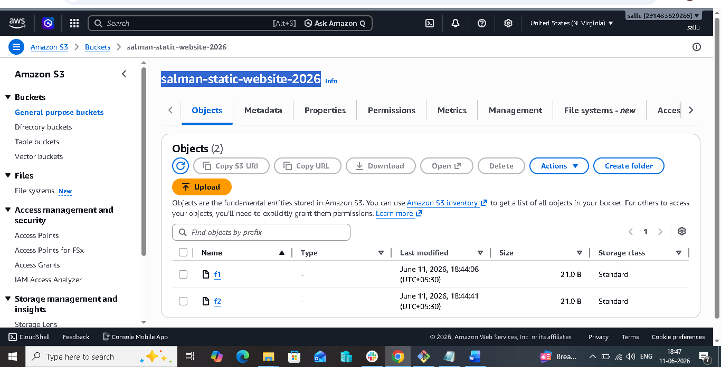

7.Write a Bash script to create an S3 bucket:-

## Objective

To create an Amazon S3 bucket using a Bash script.

## Steps

1. Install and configure AWS CLI using:

aws configure

2. Create a file named **create_bucket.bash**.

- Vi create_bucket.bash

And paste.

#!/bin/bash

BUCKET_NAME=my-s3-bucket-12345
REGION=us-east-1

aws s3api create-bucket \
--bucket $BUCKET_NAME \
--region $REGION

echo "S3 Bucket Created Successfully"

3. Add the Bash script to create an S3 bucket.

4. Save the file and provide execute permission:

chmod 755 create_bucket.bash

5. Run the script:

./create_bucket.bash

6. Verify bucket creation using:

aws s3 ls

## Result

Successfully created an Amazon S3 bucket using a Bash script and verified its creation through AWS CLI.

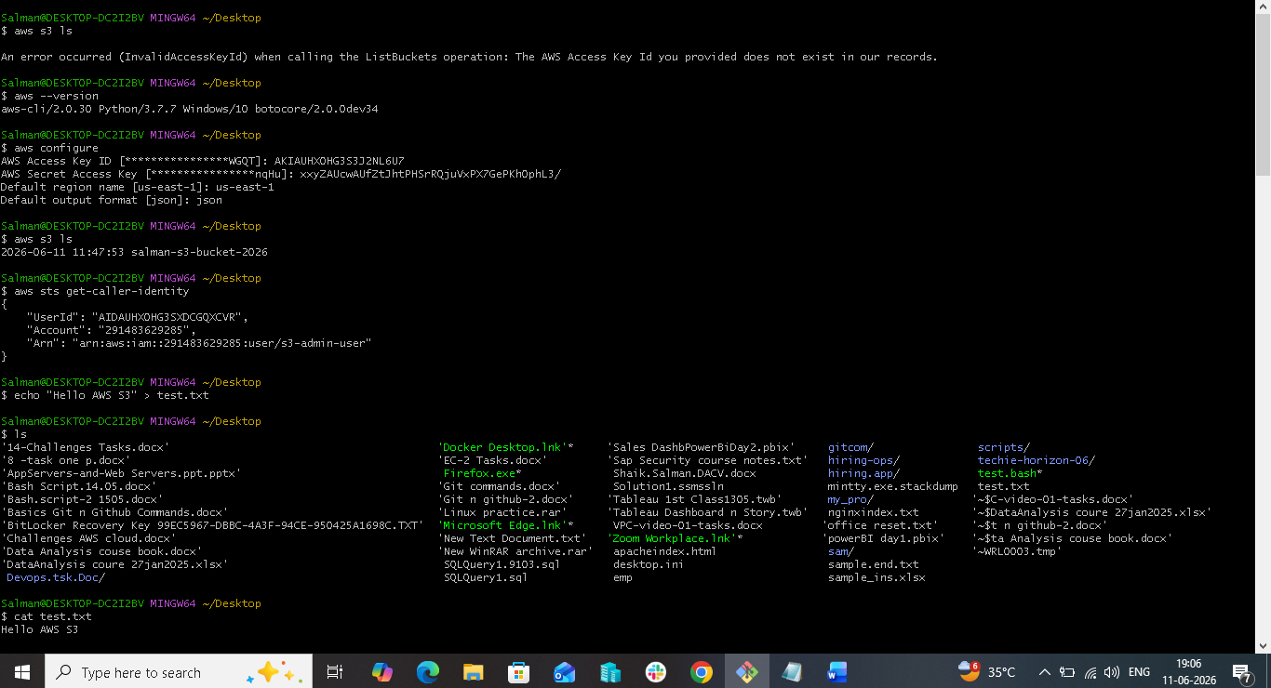

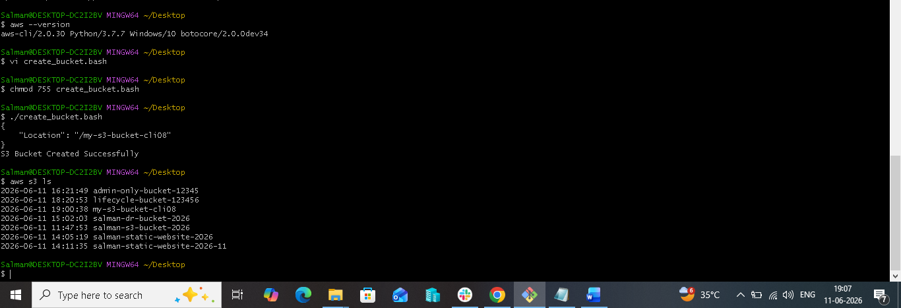

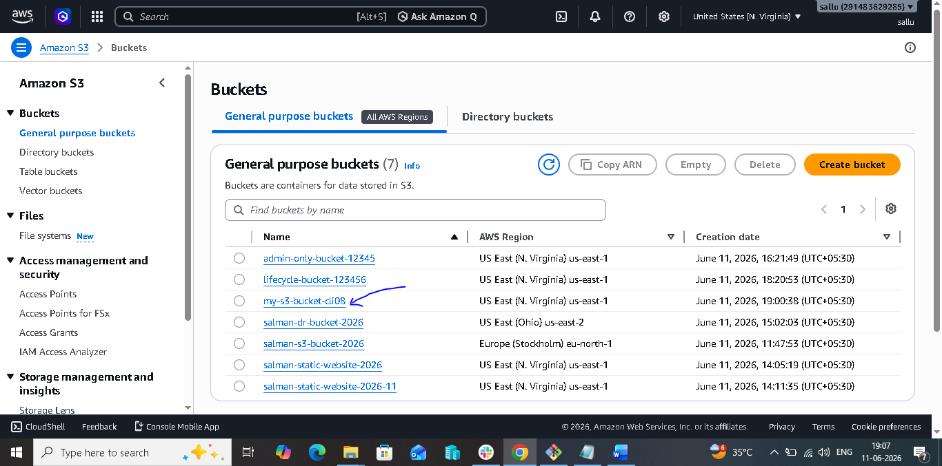
8. Upload a 1 GB file to S3 using the CLI:-

## Objective

To upload a 1 GB file from a local machine to an Amazon S3 bucket using AWS CLI.

## Steps

1. Install and configure AWS CLI using:

aws configure

2. Create a 1 GB test file on the local machine.

Command to create 1GB file :-$ dd if=/dev/zero of=testfile1GB.txt bs=1M count=1024

And to check 1GB file:-

$ ls -lh testfile1GB.txt

3. Verify that the target S3 bucket exists.

4. Use the AWS CLI upload command to upload the file to the S3 bucket.

$ aws s3 cp testfile1GB.txt s3://salman-s3-bucket-2026/

5. Verify the upload using AWS CLI or the AWS Management Console.

## Result

Successfully uploaded a 1 GB file from the local system to an Amazon S3 bucket using AWS CLI and verified the uploaded object.

